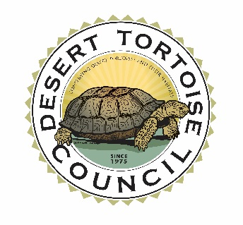
RAFFLE/AUCTION DONATION FORM
51st ANNUAL SYMPOSIUM OF THE
DESERT TORTOISE COUNCIL
(FEBRUARY 24 – 27, 2026)
The 51st Annual Symposium of the Desert Tortoise Council (Council) is scheduled for February 24 – 27, 2026 in Las Vegas, Nevada. A raffle/auction is held at the Annual Symposium as a fundraiser so the Council can continue to expand its conservation efforts for the tortoise. Tortoise populations have been declining in many areas for decades because of collecting, vandalism, loss of habitat, predation, and disease. The Desert Tortoise Council is a private, non-profit organization comprised of hundreds of professionals and laypersons who share a common concern for desert tortoises in the wild and a commitment to advancing the public’s understanding of the species. The Council has held an Annual Symposium each spring since 1976 to bring together scientists, managers, and concerned people to share the latest information available on the desert tortoise and its management.

If you are attending the Symposium or if you just have an interest in being part of the effort to conserve this amazing reptile and would like to donate a tax deductible item for the raffle/auction, then please fill out this form completely.

Donor Name:

_________________________________________________________________

Address: __________________________________________________________

__________________________________________________________________

Contact Phone Number: _____________________________________________________

Email: ____________________________________________________________

Item Description and Value:

__________________________________________________________________

_____________________________________________________________________________

The Desert Tortoise Council (Tax ID#: 95-3117744) has been recognized by the Department of the Treasury Internal Revenue Service as exempt under Section 501(c)(3) of the Internal Revenue Code. In addition, the Desert Tortoise Council is also classified as a public charity under sections 509(a)(1) and 170(b)(1)(A)(vi) of the Internal Revenue Code. Contributions to the Desert Tortoise Council qualify as deductible under section 170 of the Code, and the Desert Tortoise Council is qualified to receive tax deductible bequests, devises, transfers, or gifts under section 2055, 2106 or 2522 of the Internal Revenue Code. Information about the Desert Tortoise Council can be found at www.deserttortoise.org

Please complete this form and return to:

Desert Tortoise Council, 3807 Sierra Hwy #6-4514, Acton, CA, 93510 or send it by email to the Desert Tortoise Council’s Operations Manager, David Hedrick at (dhedrick@deserttortoise.org) or Mari Quillman at (mquillman@ecorpconsulting.com).

The form will be signed by an officer of the Desert Tortoise Council and then it will be returned to you by email or mail as a receipt for your records.

For information about mailing or picking up raffle/auction items, please contact Mari Quillman [(714) 222-5932, mquillman@ecorpconsulting.com] or David Hedrick at (dhedrick@deserttortoise.org).

The Desert Tortoise Council would like to sincerely thank you for your generous donation for the Annual Symposium. The Desert Tortoise Council is working to assure the continued survival of viable populations of the desert tortoise throughout its range. We are pleased that you have supported this goal by providing support to our cause.

Sincerely,
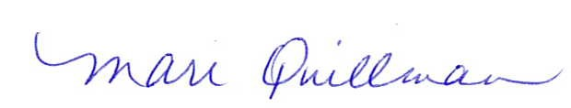
Chairman
Desert Tortoise Council

